|  |
| --- |
| **Submission: 16 December 2020** |



**Daffodil International University**

**Web Lab Final**

**Course Title: Web Engineering Lab**

**Course code: CSE418**

Submitted to:

Mr. Md. Mahfujur Rahman

Lecturer

Department of CSE

Daffodil International University.

**Submitted by :**

**Group Name: White Hat**

**Sourov Kumar Mondal ID: 173-15-1688**

**Rasidul Haque ID: 173-15-1640**

**Md Abu Seum ID: 173-15-1693**

**Md Ridoy Hasan ID: 173-15-1695**

**Abdul Karim Khan ID: 171-15-1306**

**Section: PC-A**

**Department of CSE**

***1. Output:***

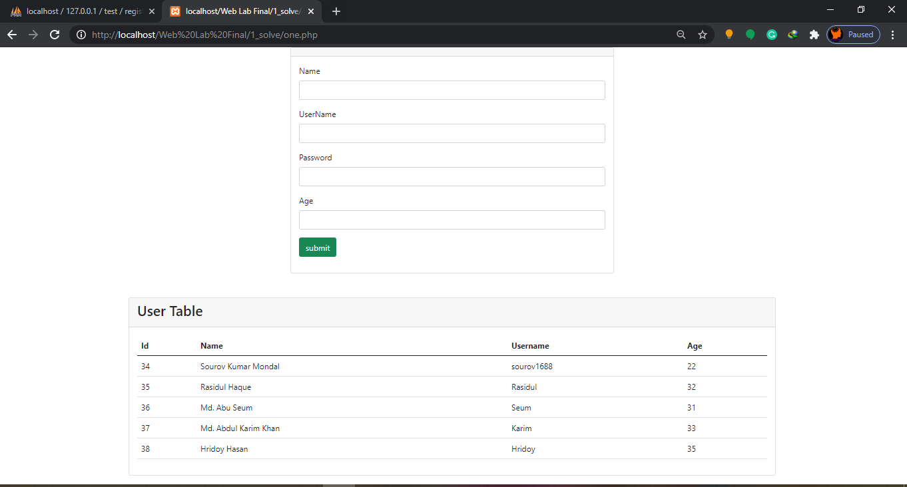

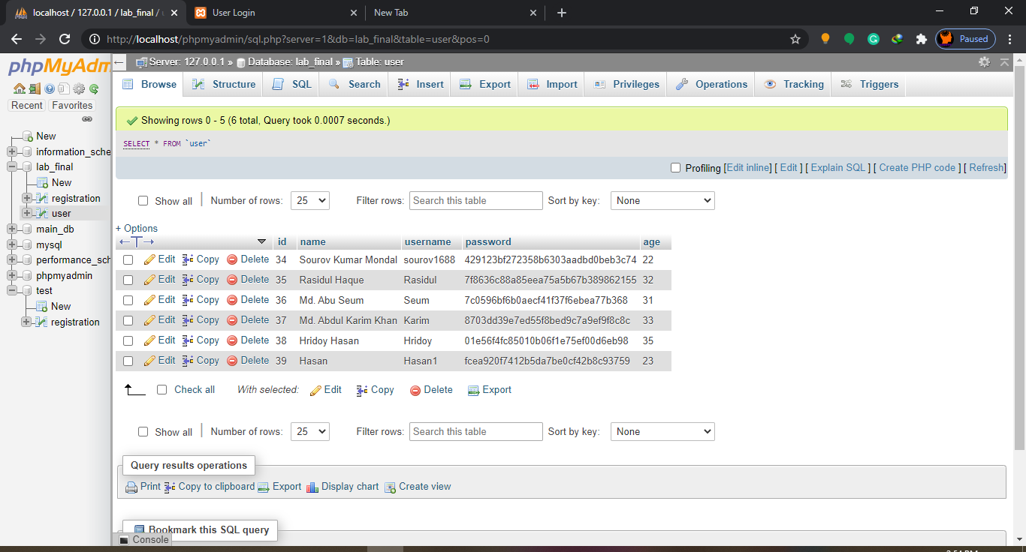***2. Output:***

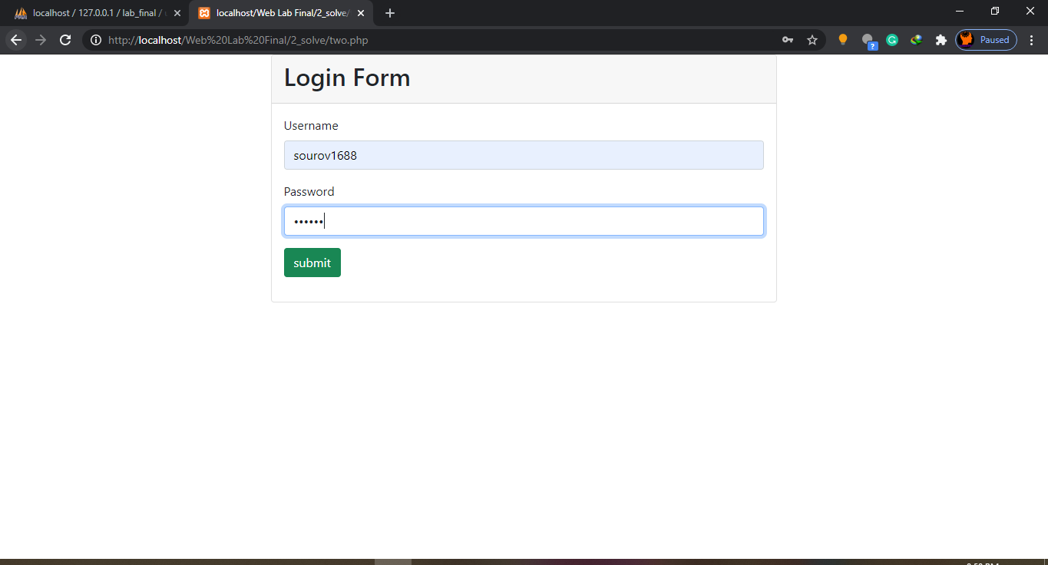

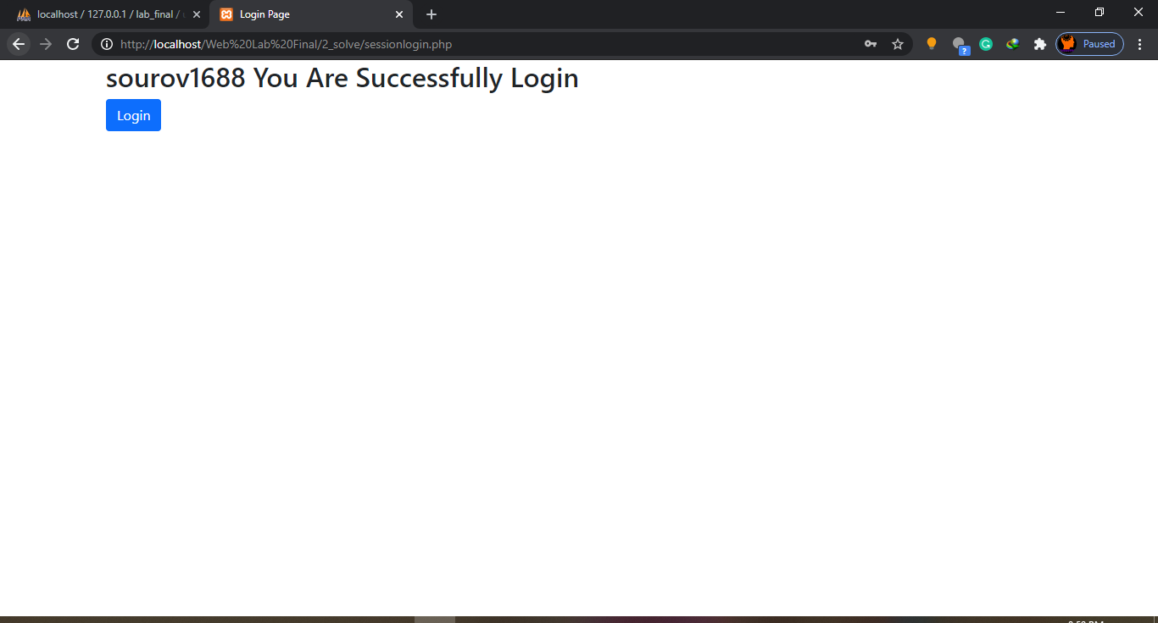

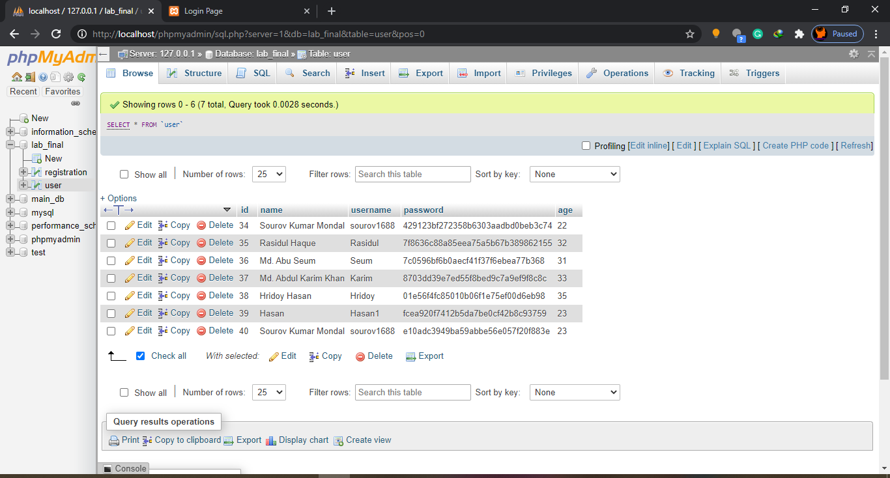

***3. Output:***

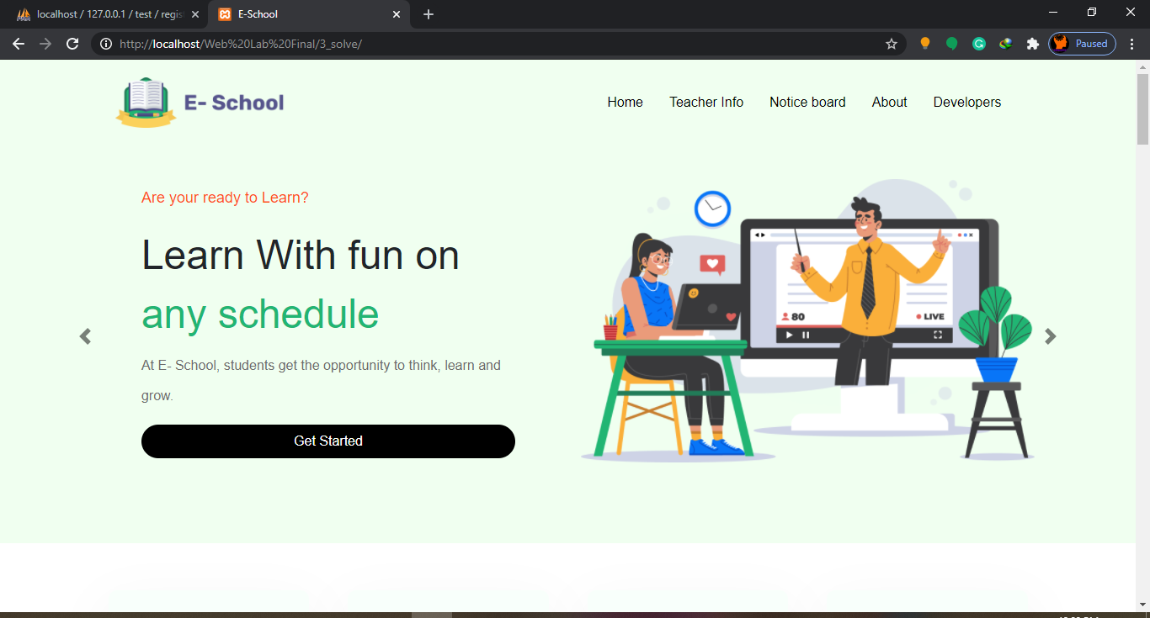

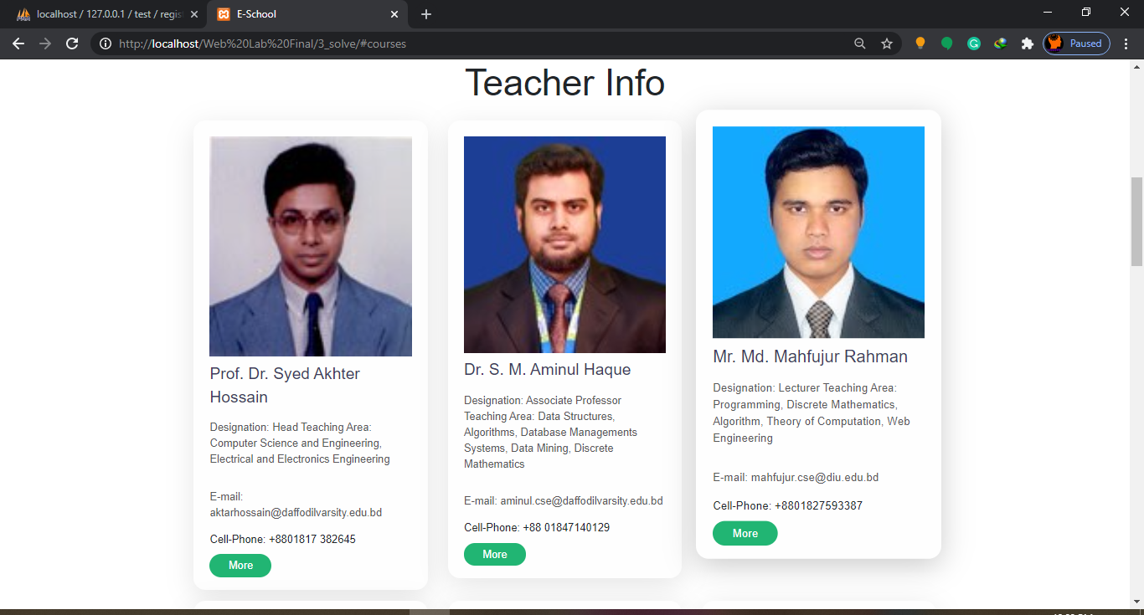

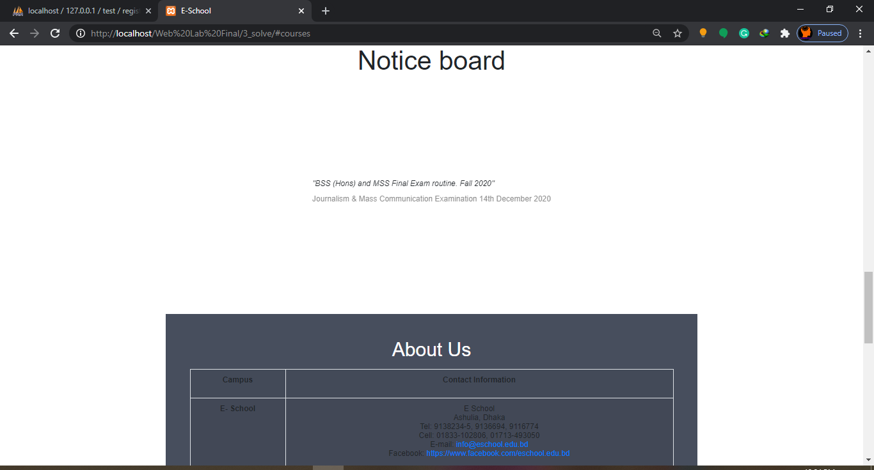

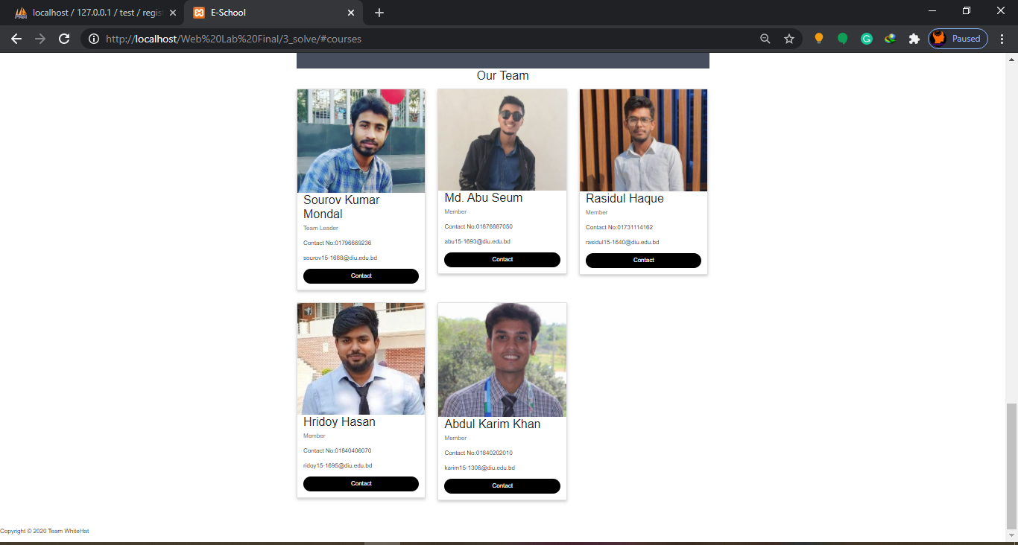

***4. Output:***

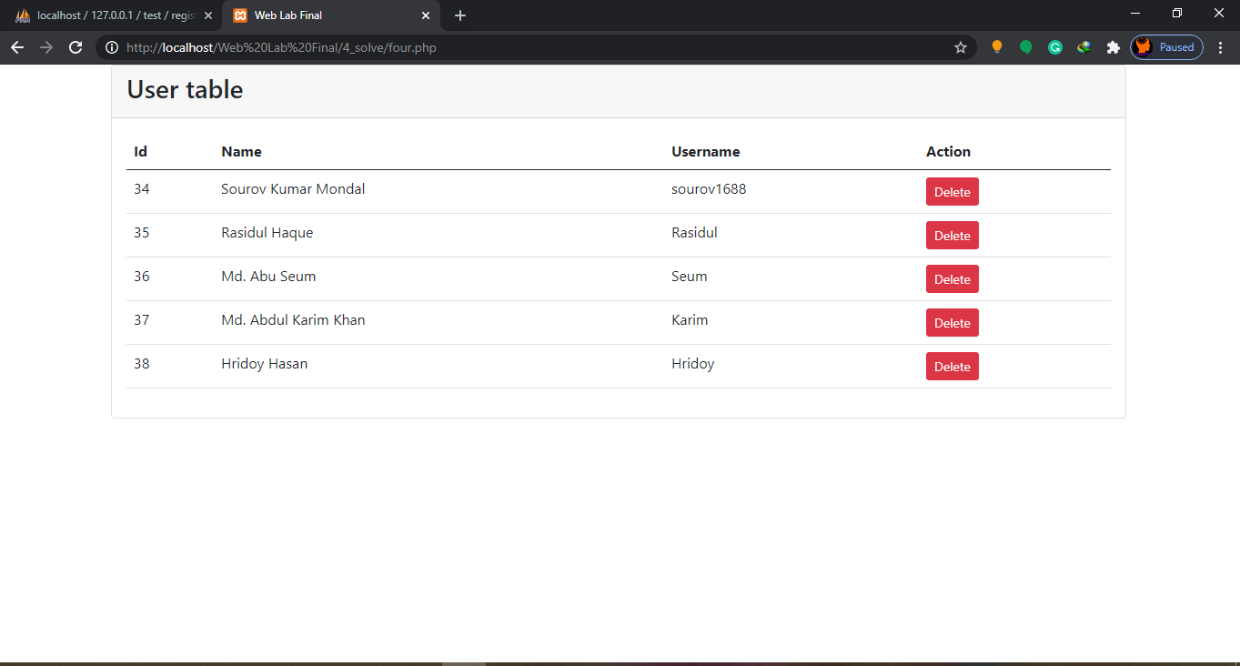

***5. Output:***

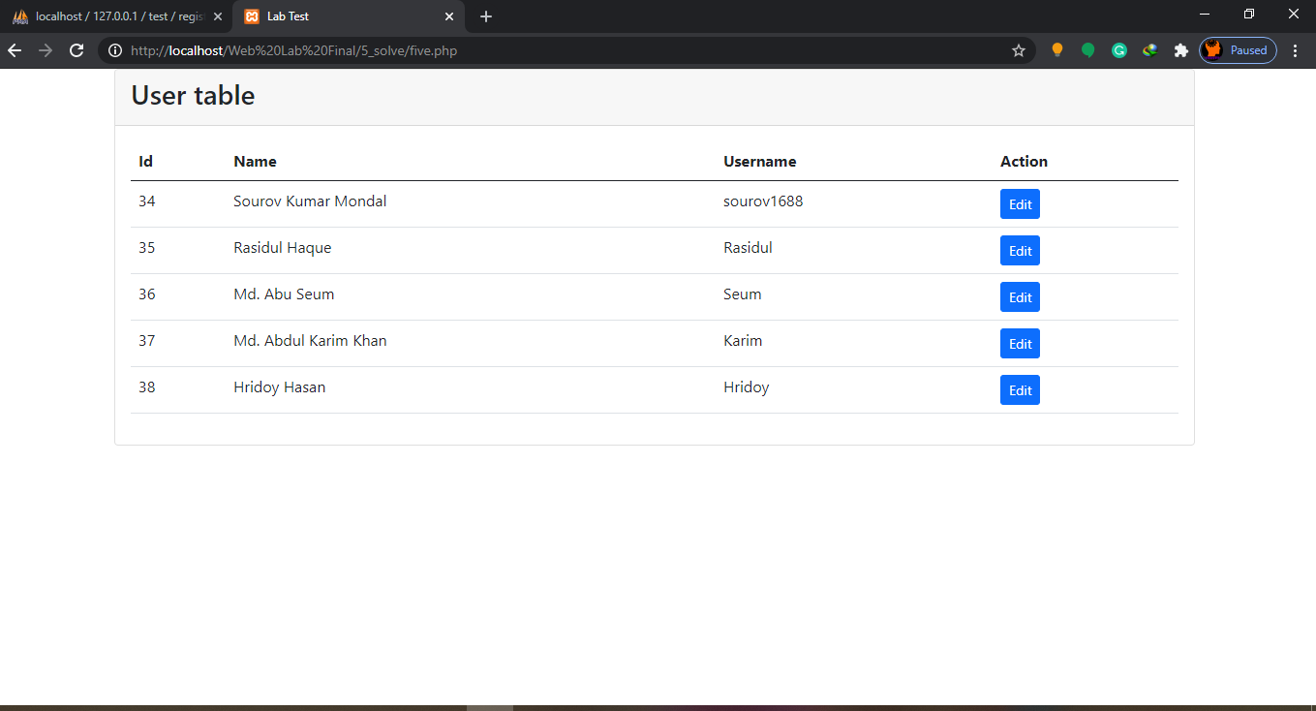

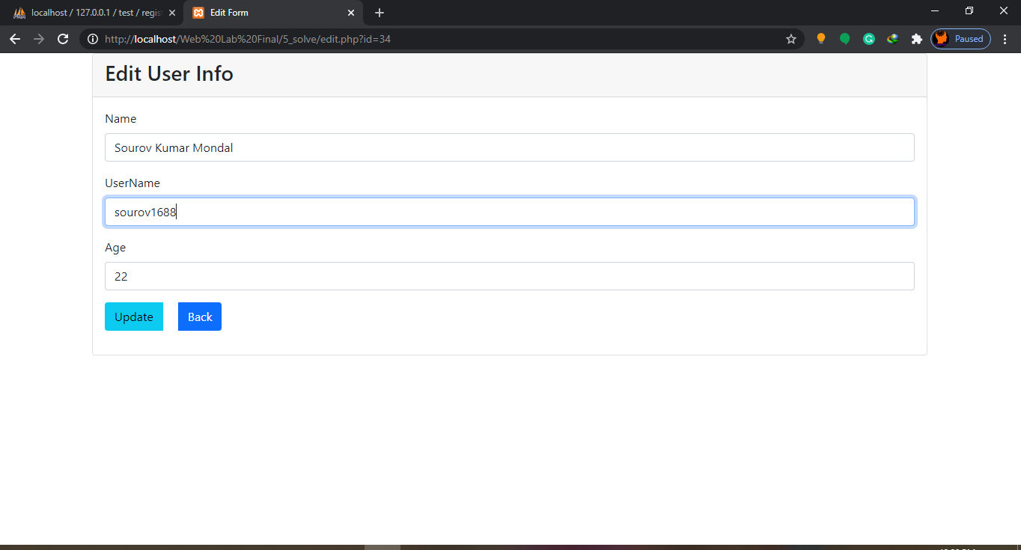

***6. Output:***

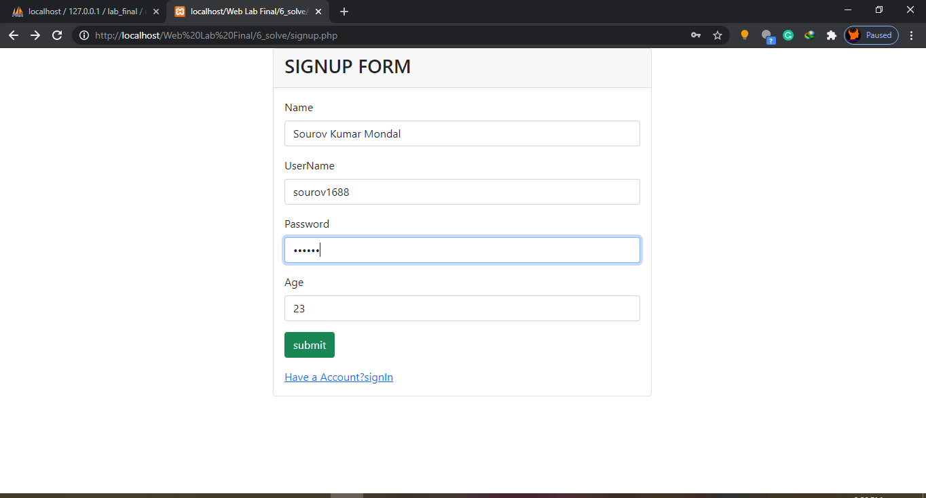

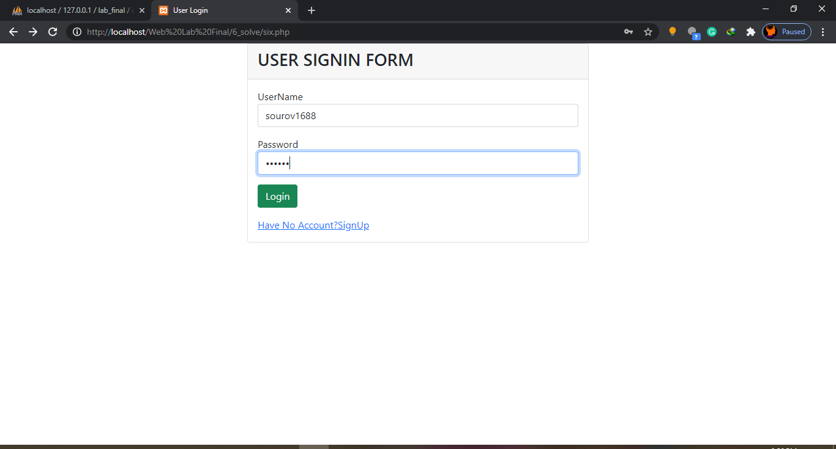

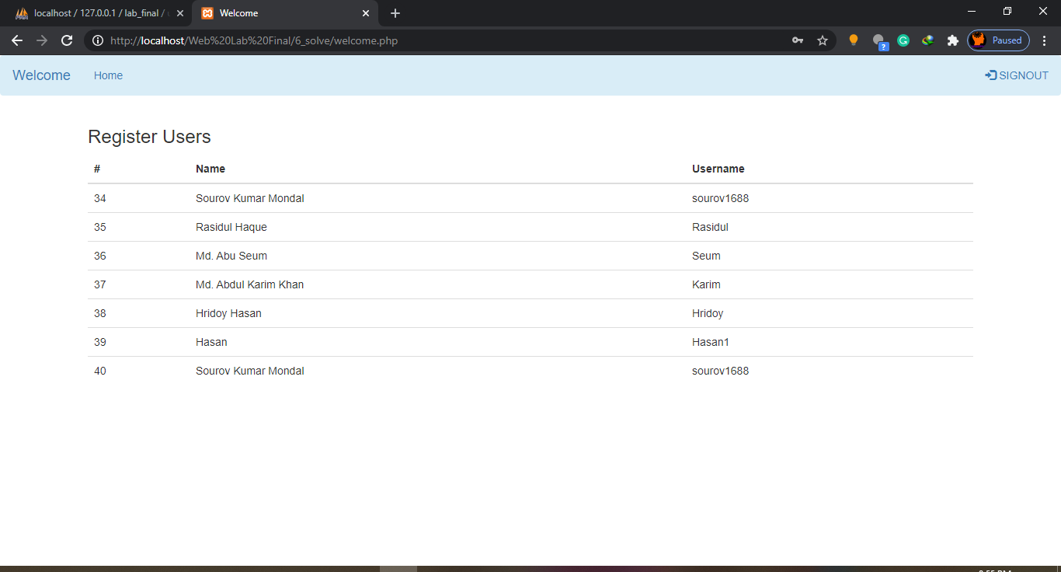



***7. Output:***

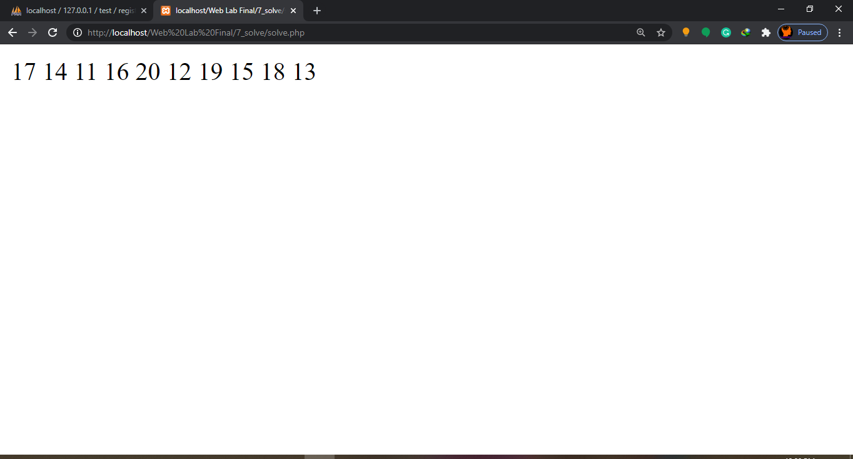

***8. Output:***

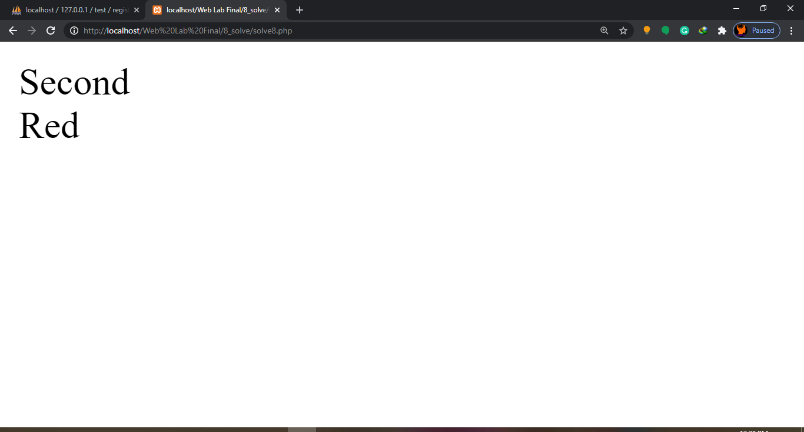

***9. Output:***

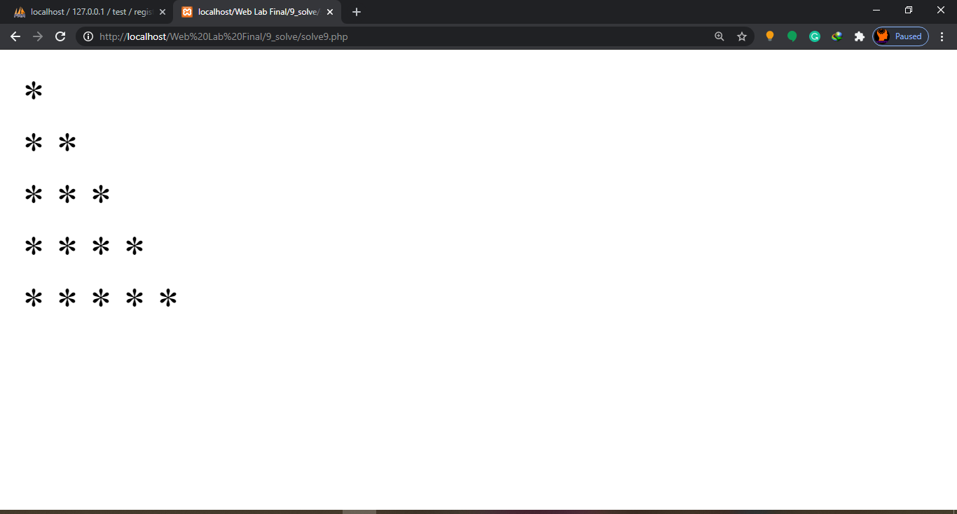

***10. Output:***

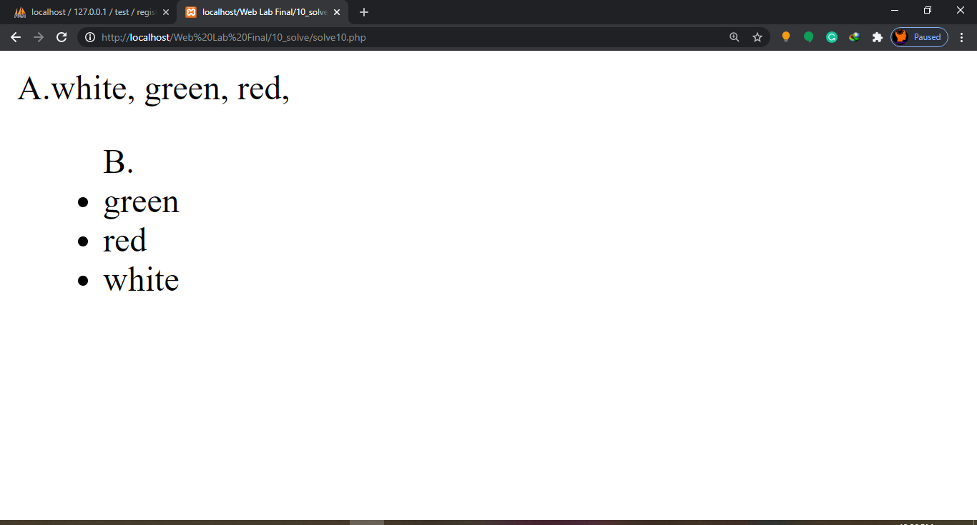

***11. Output:***

